## SHARDA UNIVERSITY

School of Engineering and Technology Internship Guidelines (Rubrics and Reports)

………… Semester Summer Internship

Student Name: Ashish Kumar Program : B.tech CSE Specialization : Core

Host Organization/Company :Sharda University Mailing Address :

[2021485739. ashish@ug.sharda.ac.in](mailto:2021485739.%20ashish@ug.sharda.ac.in)

Internship Supervisor Supervisor Title Supervisor Phone Number : Supervisor Email Address : Faculty Supervisor : Date of Evaluation :

The purpose of this assessment is to evaluate and provide the student intern with constructive feedback on his/her internship experience. The student’s grade is partially based on your evaluation of his/her/their performance on each of the internship dimensions identified below. Use the evaluation rubric to assess the student’s performance on each dimension by specifying a score based on the performance ratings and descriptors delineated in the rubric form.

**Internship Evaluation Dimensions – Grading Criteria**

|  |  |  |  |  |  |  |  |
| --- | --- | --- | --- | --- | --- | --- | --- |
| **Evaluation of Internship - Grading Rubric** | | | | | | | |
| **Evaluation Dimensions** | Performance Rating | | | | | | |
| Needs Improvement | | Meets Expectations | | | Excellent | |
| 1 | 2 | 3 | | 4 | 5 | 6 |
| Quality of Work with cognitive modeling achieved | Work was done in a careless manner; work assignments were usually late and required review; made numerous errors | | Adequately performed most work requirements; most work assignments submitted in a timely manner; made occasional errors | | | Thoroughly and accurately performed all work requirements; submitted all work assignments on time; made few if any errors | |
| Level of ability to transfer one context into another context | Asked a few questions, Students were unable or slow to understand new concepts, ideas, and work assignments; was unable or unwilling to make changes. | | In most cases, asked relevant questions; exhibited acceptable understanding of new concepts, ideas, and work assignments | | | Asked relevant questions and sought out additional information from appropriate sources; very quickly understood new concepts, ideas, and work assignments; was always willing to make needed changes and improvements | |
| Level of logic building / Programming level | Had little logic building drive and required close supervision; showed little if any interest; did not seek out additional work; suggested no new ideas or options | | In some cases, found problems to; offered some creative ideas | | | Was a self-starter; consistently sought new challenges and asked for additional work assignments; regularly approached and solved problems independently; | |
| Core inequities if any (Language Proficiency) | None | | 1 | | | >1 | |
| Attentiveness / focus during sessions | Regularly exhibited a negative attitude | | Except in a few minor instances, demonstrated a positive attitude; | | | Demonstrated an exceptionally positive attitude; attentive and proactive | |
| readiness in core field | Low | | Medium | | | High | |
| **Summary performance rating on Internship** | | | | | | | |
| **Evaluation Criteria** | | | | **Score (from above)** | | | |
| **Quality of Work with cognitive modeling achieved** | | | |  | | | |
| **Level of ability to transfer one context into another context** | | | |  | | | |
| **Level of logic building / programming level** | | | |  | | | |
| **Core inequities if any (Language Proficiency)** | | | |  | | | |
| **Attentiveness / focus during sessions** | | | |  | | | |
| **readiness in core field** | | | |  | | | |
| **Total** | | | |  | | | |



## WEATHER APP

B-TECH 4th YEAR SEMESTER: 7th SESSION: 2024-2025

# Submitted By:

Name: Ashish Kumar

**System ID:** 2021485739

# Submitted To:

Dr. Abhishek Verma

(Associate Professor)

## DEPARTMENT OF COMPUTER SCIENCE & ENGINEERING

SCHOOL OF ENGINEERING & TECHNOLOGY

SHARDA UNIVERSITY, GREATER NOIDA

## DECLARATION

We hereby declare that the project entitled is an outcome of our own efforts under the guidance of Dr. Abhishek Verma. The project is submitted to the Sharda University for the partial fulfillment of the Bachelor of Technology Examination 2024-25.

We also declare that this project report has not been previously submitted to any other university.

Ashish Kumar (210101123)



## CERTIFICATE

We are writing to inform that Ashish Kumar of Sharda University has successfully undergone the summer bootcamp, partially in the partial fulfillment of the Bachelor of Technology Examination 2024-2025 of Sharda University.  
It is a record of actual work performed by them during the period between JUNE 2024 and JULY 2024..

Ashish Kumar (210101123)

Dr.Abhishek Verma

(Associate Professor)



## ACKNOWLEDGEMENT

Thank you to those who provided me with the chance to complete my report, I would like to express my most sincere appreciation. Every success of the undertaking of any projects other than mine, is mainly dependent on faces and guiding of several others. We would want to take this opportunity to appreciate all those that have participated in the completion of this project. We wish to express our heartfelt thanks to Dr. Abhishek Verma. They really appreciate all of his help. After each attendance of his meeting, we leave the room highly motivated and with so much enthusiasm. This project would have never been viable except for his guidance. The suggestions and help from each individual Member who has been involved and still is agreement . Every Member's advice, assistance and input who has contributed and continues to contribute to what.



## ABSTRACT

 The Weather Forecasting Application is an interactive real-time web application, designed utilizing the MERN (MongoDB, Express.js, React, Node.js) technology stack. This application gives the current weather information such as temperature, humidity, wind speed, forecasts of given places etc. The weather forecast is powered by APIs. The weather application is a web-based application which uses APIs to get weather information. It offers features like weather reports for a specific city, 7 day forecast, weather alerts which can be customized. This application is meant for the general public and it aims for providing up-to-date weather information, forecasting accurately and includes real time features, which makes it practiceable in monitoring weather.

## TABLE OF CONTENT

|  |  |  |
| --- | --- | --- |
| **Sr.**  **No.** | **Content** | **Page no.** |
|  | Title Page | 01-02 |
|  | Declaration | 03 |
|  | Certificate | 04 |
|  | List of Figures |  |
|  | Acknowledgement | 05 |
|  | Abstract | 06 |
| **1.** | **INTRODUCTION**   1. Introduction 2. Aim and Objective | 09  10 |
| **2.** | **METHODOLOGY**   1. Methodology | 11-12 |

|  |  |  |
| --- | --- | --- |
| **3.** | **PROJECTS**   1. Major Project 2. Challenges | 13  14 |
| **4.** | **RESULT**   1. Snapshots of Source Code 2. Snapshots of Output | 20  20 |
| **5.** | **CONCLUSION**   1. Conclusion | 20 |
| **6.** | **REFERENCES** | 20 |

**INTRODUCTION**

Full-stack development has become a crucial skill set in today's quickly changing technological scene, allowing developers to build reliable, dynamic online applications that satisfy a wide range of user needs. During my time at the coding bootcamp, I thoroughly studied the MERN stack, which consists of Node.js, React.js, and MongoDB. This potent blend of technologies fosters a unified understanding of both front-end and back-end development while enabling developers to create fluid, high-performance applications.

I worked on practical projects during the course that helped me better grasp each technology and demonstrated how crucial it is to integrate different parts to produce an application that works as a whole. I gained personal expertise with everything from using React to create user interfaces to Node.js and Express to implement server-side functionality. I had the good fortune to attend college with a curriculum that prioritized practical instruction, group projects, and real-world applications. This immersive setting stoked my interest and gave me the fundamental knowledge I need to succeed in this fast-paced industry. The coursework prepared me for my investigation into full-stack development by covering a variety of programming languages, frameworks, and technologies. Outside of the classroom, I devoted a lot of time to practical projects and independent study at home. I used online tools to further my understanding of important technologies like HTML, CSS, JavaScript, Node.js, and React, including tutorials, coding bootcamps, and documentation. By using the principles I learnt on personal projects, I was able to hone my abilities and create a portfolio that shows my development as a developer.

This report outlines my full-stack development learning path, emphasizing the knowledge I gained, the difficulties I encountered, and the tasks I finished throughout this life-changing opportunity.

### Aim and objective

The primary aim and objectives of this bootcamp were carefully crafted to ensure a comprehensive and holistic learning experience in web development. Through an emphasis on essential technologies, tools, and best practices for front-end and back-end development, the bootcamp equips students with the skills they need to create, implement, and manage whole web applications. These objectives were as follows:

1. **Comprehensive Full-Stack Development Training:** Provide an in-depth understanding of front-end and back-end technologies, including HTML, CSS, JavaScript, Node.js, Express, MongoDB, and React. Develop the ability to design, create, and manage both client-side and server-side components of web applications..
2. **Hands-On Learning and Real-World Projects:** The bootcamp aimed to provide practical exposure to solving complex coding problems efficiently. Through a series of hands-on exercises, coding challenges, and mock interviews, I sought to improve my problem-solving skills, optimize algorithmic performance, and develop the ability to tackle time and space complexities. This objective aimed to sharpen my competitive programming skills and prepare me for technical interviews.
3. **Problem-Solving and Debugging Skills:** Cultivate the ability to solve complex programming challenges, debug code efficiently, and optimize web applications for performance and scalability.
4. **Career Readiness and Professional Development** :Prepare students for technical interviews and job placement in the field of full-stack development. Provide career guidance, including resume building, technical interview preparation, and networking opportunities within the tech community**.**

## Methodology

The bootcamp was structured to provide an immersive, hands-on learning experience designed to quickly equip participants with the skills required to build full-stack applications. The methodology was divided into various stages, each focusing on different aspects of web development, from foundational concepts to advanced technologies. Below is an overview of the typical methodology followed in the bootcamp:

* + **Hands-On Learning Approach:**
* The bootcamp emphasized learning by doing, ensuring that every theoretical concept was immediately reinforced with practical implementation. Participants were expected to write code, build applications, and solve real-world problems throughout the course..
  + **Project-Based Curriculum:**
* A project-based approach was central to the bootcamp. Participants worked on projects such as building a weather app, e-commerce platforms, and social media clones. These projects were designed to simulate real-world scenarios, where each project integrated multiple concepts learned across different technologies.
  + **Mentorship and Guidance:**
* Each participant had access to mentors who provided guidance and support throughout the bootcamp. Mentors helped clarify concepts, reviewed code, provided feedback, and offered career advice.
* Code reviews were a crucial part of the process, where peers and instructors provided constructive feedback to help participants improve their code quality and problem-solving techniques.
  + **Full-Stack Coverage:** 
    - The curriculum was designed to cover both front-end and back-end technologies, giving participants a comprehensive understanding of full-stack development.
    - Front-End: HTML, CSS, JavaScript, and front-end libraries like React were taught, focusing on creating interactive and responsive user interfaces.
    - Back-End: Node.js, Express.js, and MongoDB were covered to equip participants with skills for building robust server-side applications.
    - Version control: Git and GitHub were used extensively throughout the course for managing code repositories and collaborative development.
  + **Soft Skills Development:**
  + In addition to technical skills, the bootcamp included training in soft skills, such as communication, teamwork, and time management.
  + Technical communication: Participants were trained to effectively communicate their ideas and solutions, both in written and verbal formats.
  + Resume building and interview prep: The bootcamp also helped participants prepare for technical interviews, offering mock interviews and guidance in creating industry-standard resumes.

## Project:-

## Weather Forecast App

**Description:** The Weather Forecast App is a user-friendly web application designed to provide real-time weather information for any location in the world. By leveraging data from reliable sources like the OpenWeather Map API, the app offers users accurate weather conditions, including temperature, humidity, wind speed, and future forecasts.

The app features a search functionality that allows users to quickly retrieve weather data for their desired city. One of its key highlights is the dynamic user interface, which changes the background image based on the current weather conditions, offering a visually engaging experience. Whether it’s a sunny, cloudy, or rainy day, the app reflects the environment, creating an interactive and immersive interface.

Additionally, the app is fully responsive, making it accessible on different devices, from smartphones to desktops. It also provides detailed information like a 3- to 5-day weather forecast, helping users plan their activities. With smooth animations, accurate weather icons, and geolocation capabilities, the Weather Forecast App serves as a practical tool for anyone seeking quick, reliable, and visually appealing weather updates.

This project demonstrates the integration of APIs, front-end design, and real-world problem-solving to deliver a fully functional and engaging web application

**Objectives:**

* **Real-Time Weather Data Access:**
  + Integrate with a reliable weather API (e.g., OpenWeatherMap) to fetch up-to-date weather data for any city.
  + Display key weather metrics such as temperature, weather condition (sunny, cloudy, rainy, etc.), wind speed, humidity, and forecasts for upcoming days.
* **Dynamic Backgrounds Based on Weather Conditions:**
* Ensure that the weather-related backgrounds reflect the current weather of the selected location.
* **Responsive and User-Friendly Design**:
* Design the app to be fully responsive and accessible on all device sizes (desktops, tablets, smartphones).

### Tools and Software used:

### 1.HTML5:

### Used to structure the content and layout of the web pages, ensuring the app is accessible and SEO-friendly.

### 2.CSS3:

### Responsible for styling the app, including the layout, fonts, colors, and animations.

### Utilized for responsive design to ensure the app works on various devices and screen sizes.

### Includes features like background changes based on weather conditions and subtle animations.

### 3.JavaScript (ES6+):

### The core scripting language used to build the interactive features of the app.

### Manages the fetching of real-time weather data from the API and dynamically updates the user interface.

### Handles user input (e.g., city search), error handling, and displaying weather information.

### 4.jQuery:

### Simplifies JavaScript operations like DOM manipulation, event handling, and AJAX requests to the weather API for real-time data retrieval.

### Improves the app’s interactivity with less code.

### 5.OpenWeatherMap API:

### Provides real-time weather data for the app.

### The API is used to fetch weather details such as temperature, and conditions (clear, rain, clouds, etc.) based on the user’s query.

### Weather icons from the API are used to display visual indicators of current conditions.

### 6.Bootstrap (optional):

### A front-end framework that may be used to streamline the creation of a responsive layout and ensure cross-browser compatibility.

### Provides pre-built components for forms, buttons, and grids to enhance the UI/UX.

### 7.Version Control (Git & GitHub):

### Git is used to track changes in the source code, enabling collaboration and version management.

### GitHub is used for hosting the project repository, allowing easy sharing and version tracking

### 8.Visual Studio Code (VS Code):

### The primary code editor used to develop the app. It supports extensions for JavaScript, HTML, CSS, and Git integration.

### 9.Axios or Fetch API:

### Axios (or the native Fetch API) is used for making asynchronous HTTP requests to the OpenWeatherMap API. It handles the retrieval of weather data and the dynamic updating of the app interface.

### Challenges:

### Throughout the course of the bootcamp, several challenges arose, each offering valuable lessons and contributing to a deeper understanding of full-stack development. These challenges were both technical and non-technical, requiring adaptability, persistence, and a constant willingness to learn.

1. **Mastering JavaScript Frameworks (React):**

* Challenge: React.js, as one of the key frameworks used in the bootcamp, posed challenges in understanding concepts like state management, component lifecycle, and hooks. Writing reusable components and handling complex UI states were initially difficult.
* Solution: Building small, focused projects helped in gaining confidence with React. Frequent code reviews and debugging sessions with mentors clarified many core concepts. Understanding React’s ecosystem, including libraries like Redux for state management, also provided better insight.

**2.Version Control with Git and GitHub:**

* Challenge: For those new to Git, managing version control, resolving merge conflicts, and collaborating on projects using GitHub introduced several challenges. Understanding the workflow, including branching and pull requests, required practice.
* Solution: Frequent use of Git in daily tasks helped build comfort with commands like git commit, git push, and git pull. Team-based projects introduced the need for collaboration, which led to better understanding of branching strategies and resolving conflicts.

**3.Working with Databases (MongoDB):**

* Challenge: Understanding NoSQL databases like MongoDB, and integrating them with backend servers, was a challenge. Querying and manipulating data in a non-relational database required a different mindset compared to traditional SQL.
* Solution: Practice through building CRUD (Create, Read, Update, Delete) operations in projects helped build familiarity. Understanding Mongoose, an Object Data Modeling (ODM) library, also simplified data handling in MongoDB.

**4.Debugging and Problem-Solving:**

* Challenge: Debugging complex code, particularly when working with asynchronous functions or dealing with front-end and back-end integration issues, was a significant challenge. Understanding and fixing bugs, especially in larger projects, required strong problem-solving skills.
* Solution: Systematic debugging using tools like Chrome DevTools for front-end and logging for back-end proved invaluable. Breaking problems into smaller parts and seeking help from mentors when needed helped streamline the debugging process.

**5.Dealing with API Limitations and Errors:**

* Challenge: Working with third-party APIs, like the OpenWeather API, often led to challenges with rate limits, data inconsistencies, and API errors. Handling and presenting error messages in a user-friendly way was also difficult.
* Solution: Learning to implement error handling and retry mechanisms helped mitigate API-related issues. Ensuring that the user experience was not affected by API limitations, such as by showing fallback data or messages, improved the robustness of the application.

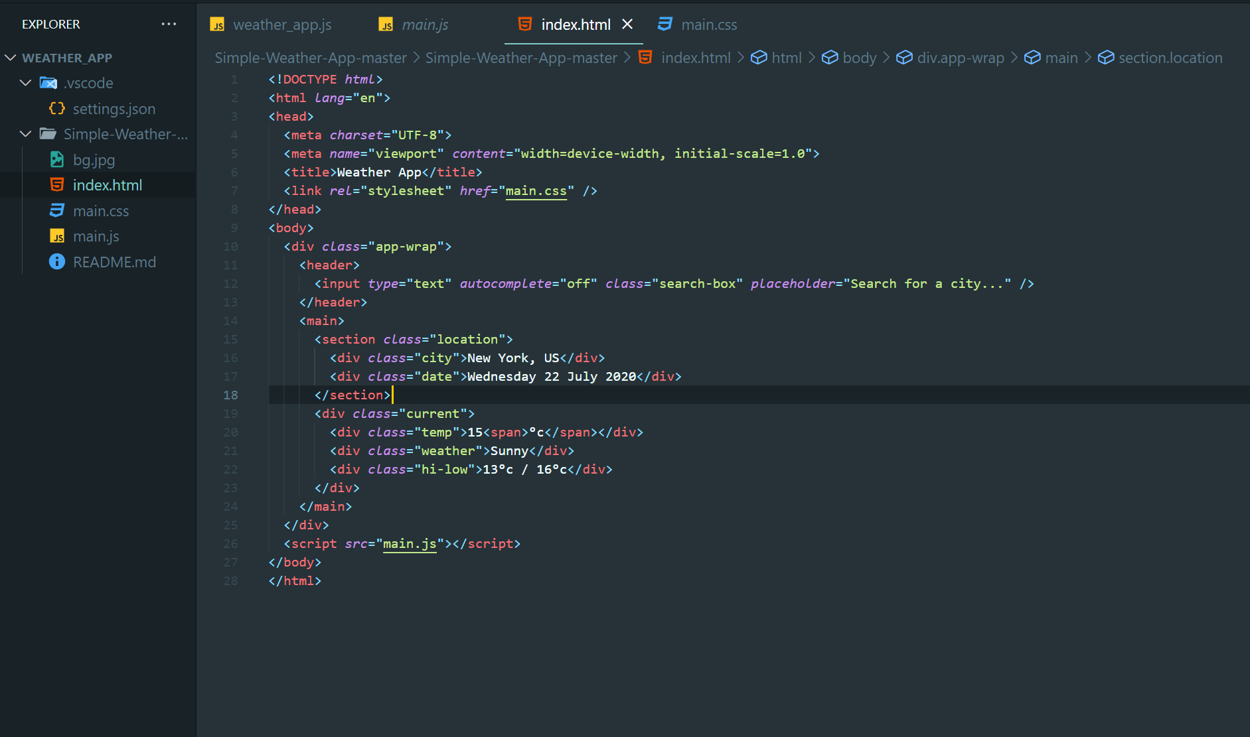**Source code:**

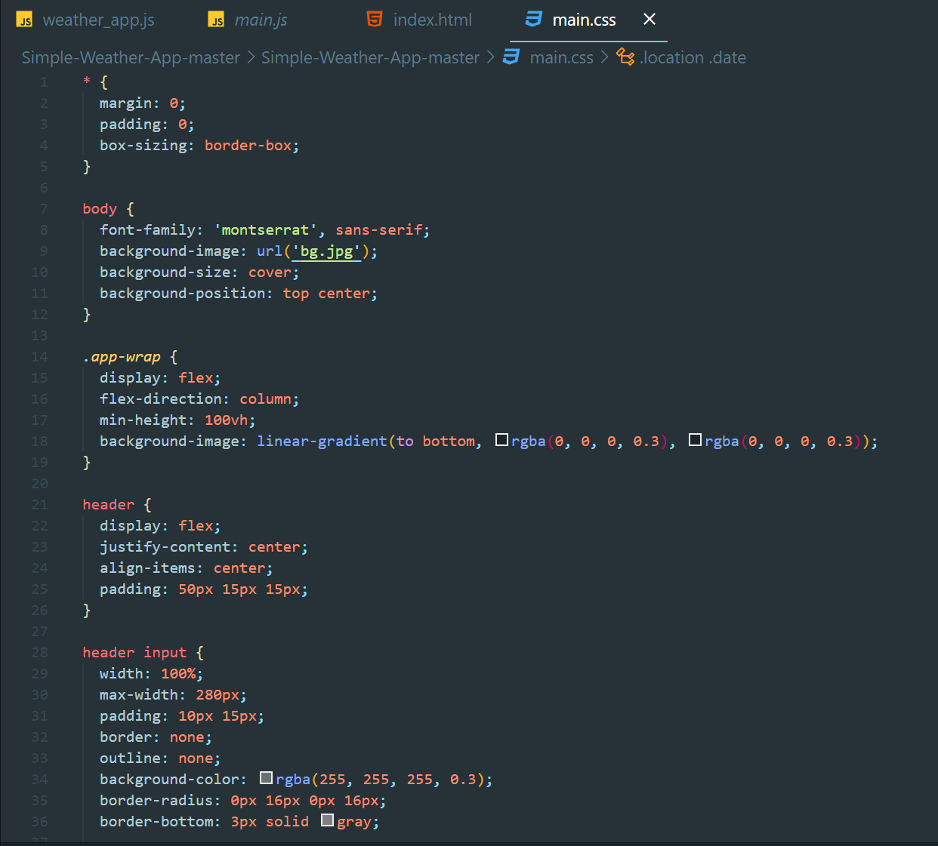 Fig 1: HTML Code

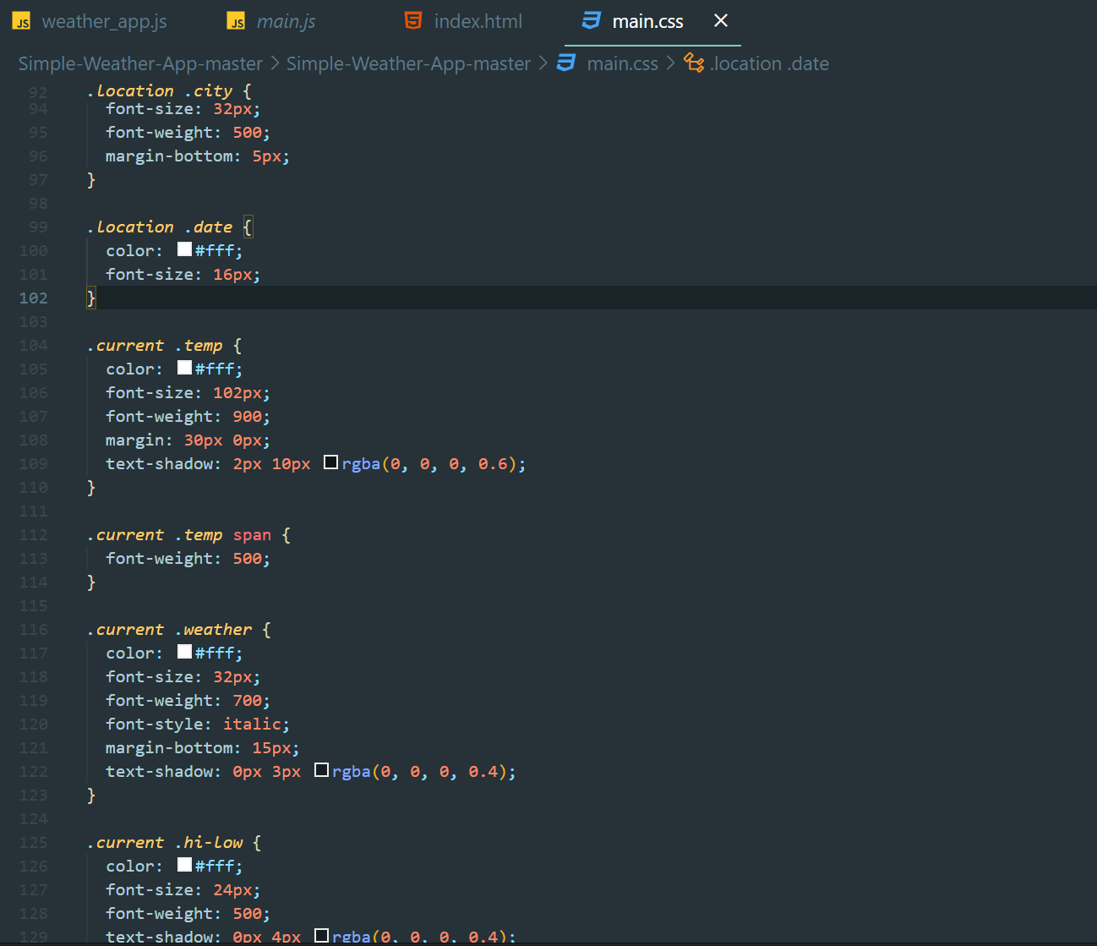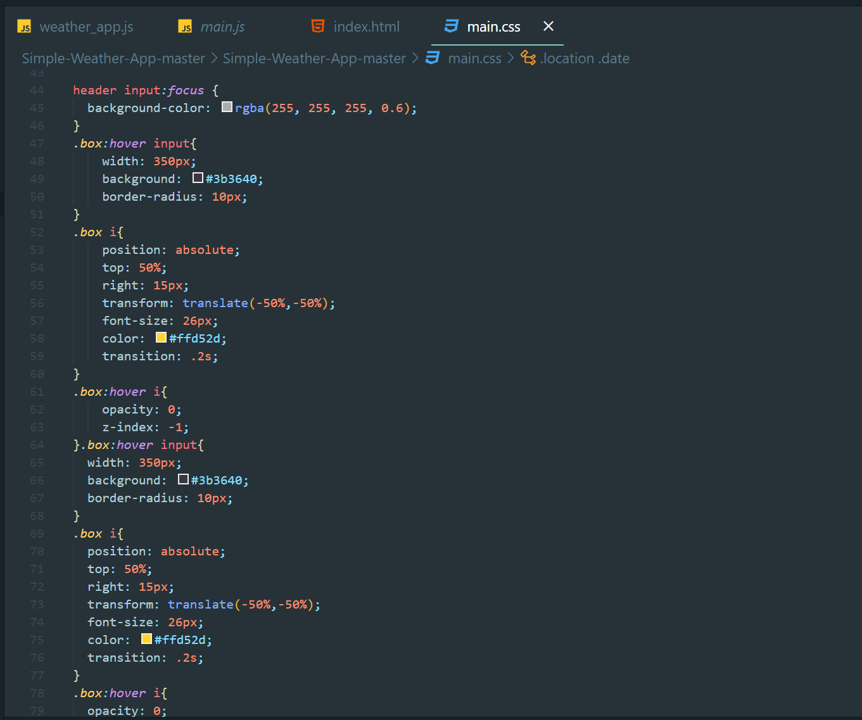

## Fig 2: CSS Code

## 

## Fig 3: JavaScript Code

## 

## 

## RESULTS

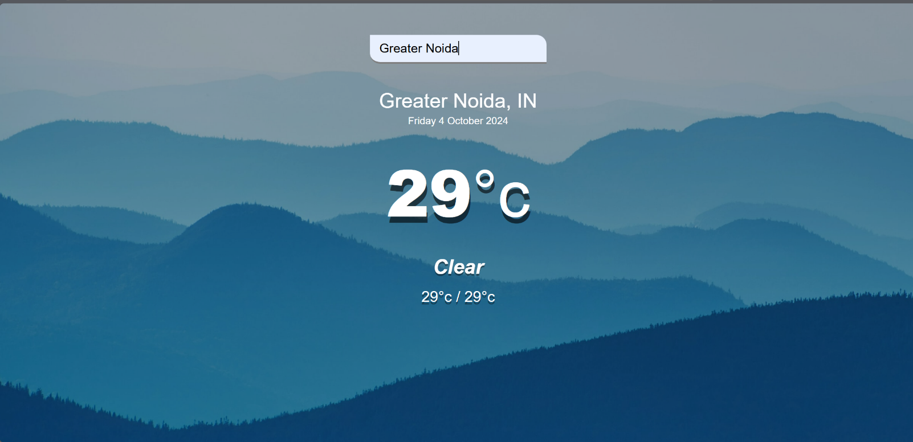

**Future Scope:**

The Weather Forecast App has a solid foundation, but there are several areas for future enhancement and expansion to improve its functionality, user experience, and versatility. Some potential directions for future development include:

* **Extended Forecast Feature:**
* Implementing a feature to provide a 7-day or 14-day weather forecast would offer users more insight into future weather trends. This could be done by leveraging additional features from the OpenWeather API or integrating similar weather services that offer longer-term forecasts.
* **Geolocation-based Weather Updates:**
* Adding a geolocation feature that automatically detects the user's current location and displays weather updates for that location could improve user convenience. This can be implemented using the HTML5 Geolocation API in combination with weather data APIs.
* **Historical Weather Data:**
* Including access to past weather data would allow users to view trends over time. This could be useful for users interested in analyzing past weather conditions for specific regions and dates.
* **Weather Alerts and Notifications:**
* Integrating real-time weather alerts for severe conditions (e.g., storms, heatwaves) could enhance the app’s usefulness, especially for regions prone to extreme weather events. Push notifications or email alerts can be included to inform users of these updates.

**CONCLUSION**

The Weather Forecast App project was a rewarding experience that not only showcased my technical skills but also reinforced my understanding of full-stack development. The project provided hands-on experience in integrating front-end and back-end technologies, using third-party APIs, and building a responsive and dynamic user interface. Additionally, it emphasized the importance of time management, error handling, and debugging, all of which are critical to building efficient applications. This project demonstrated my ability to apply the concepts learned throughout the bootcamp and create a functional, user-friendly web application. As I move forward in my development journey, the knowledge and experience gained from this project will serve as a solid foundation for tackling more complex and innovative web development challenges..

In conclusion, this bootcamp has provided me with the essential skills and confidence to excel in the field of software development. The structured approach to learning **Full-Stack** and applying it through practical projects has deepened my technical foundation and prepared me to tackle more advanced challenges. As I move forward in my career, I am excited to continue learning and contributing to the ever-evolving tech industry.

## REFERENCES

1. YouTube Video:
   * Title: "Complete WebDev course using MERN stack - by LOVE BABBAR "
   * Channel: Codehelp
   * URL: https://www.youtube.com/playlist?list=PLDzeHZWIZsTo0wSBcg4-NMIbC0L8evLrD
   * Published Date: May 05, 2023
2. Intrainz Website:
   * Title: "EazyBytes: My Source for Online Learning"
   * Website: EazyBytres
   * URL: https://eazybytes.com/
3. Gemini AI ):
   * Source: gemini.google.com
4. Bootstrap framework:
   * URL : https://getbootstrap.com/